**Interactive Quiz App**

**Overview**

The purpose of the project is to design an interactive quiz app that will have the drop and drag functionality and an interface that allows matching correct definitions to terms.

In addition, the quiz has a timer that displays time elapsed for the duration of the game, and a show score button that displays the number of correct matches of terms and definitions.

**Constraints**

* Limited amount of time for the delivery of the Project.
* Limited Framework are permitted such as angular or JQuery library.

**Extra Points**

* Set the quiz to have 5 rounds.
* With each round, the total number of terms reduces 5.

**Background**

Previously, I had experiences working on projects using C++ and Java programming languages, but zero experience working with JavaScript, CSS, and HTML. Learning how JavaScript, CSS and HTML work together as a whole for app development is an entire new experience for me. With very limited time and limited experiences, I decided to solve the problem by dividing the big problem into subunits known as proof of concepts. The POCs that I focused on are:

* Timer
* Undo Button
* Drag and Drop
* Show Score
* CSS Styling

When “play button” is clicked, the timer sets off, and the terms are shuffled. The “play button” switches to “end button”. The “end button” will stop the timer and disable dragging more items.

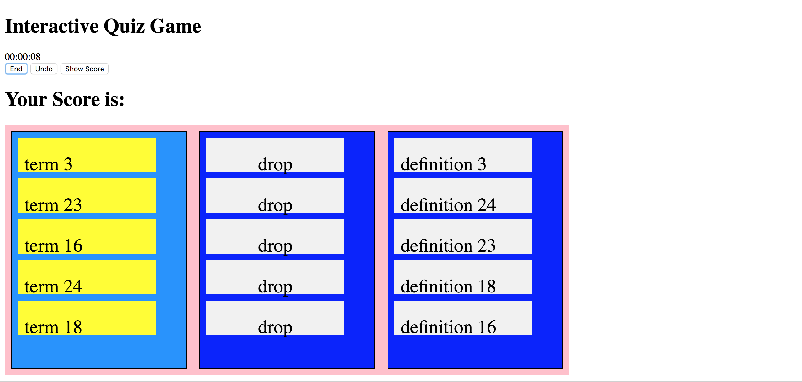

The drag and drop functionality allows the terms to be dragged and dropped at the dropbox area. The “undo button” is implemented using a stack(Last-In-First-Out), which allows the last item dropped to return to its original position.

Finally, when “Show Score button” is invoked, the matched item is highlighted green, which indicates correct. The unmatched items is highlighted red, which indicates incorrect.

The “Show Score button” also displays the score, which is the numbers of correct matches you got.

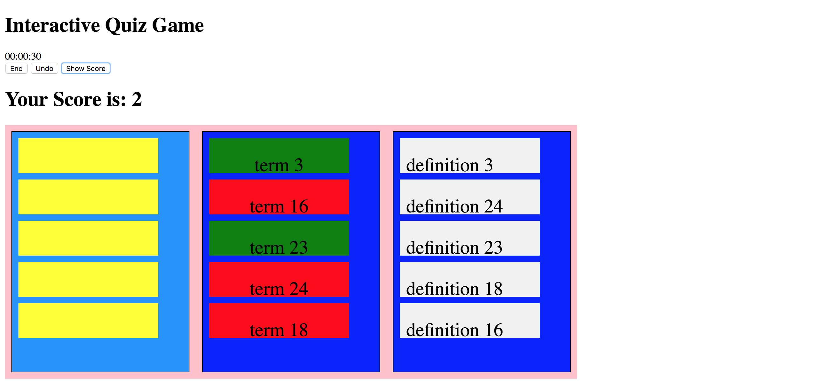

**Potential Improvement**

There are many areas that can be improved on. Some are listed below:

1. Making the App interface to look nicer.
2. Adding features such as user input to allow user to input his or her name to have an more interactive user interface.
3. Keep track of different players, so at the end of the game, each player and the corresponding score is displayed as a list.
4. Adding unit test.
5. Loading the data from a database

**Conclusion**

Through this project, I didn’t just learn the syntax of CSS, HTML, and JavaScript, but also got an overlook of how the three work together as a whole for front-end development. I learned the important skill of divide and conquer and using proof of concepts. Solving each small problem at a time instead trying to tackle all the problems at once.

Considering the very limited time and skill, I learned to fully utilize the debugging tool and watch function to keep track of my steps. Another helpful skill I learned is to test my code as I write to keep track of my progress constantly. Finally, I learned the importance of documenting my script for future reference.

Learning these fundamental skills will allow me to become versatile and adaptable to any new language and knowledge that I encounter in the future projects.